**Proctor’s Guide: Experiment with Experts**

**About the experiment**

Participants will be given a Microsoft Hololens 2 with the prototype program loaded into it. The proctor will ask participants to control our collaborative robot, ABB CRB 15000, using the custom bounding box interface. To make the testing more exciting, participants will be invited to stack 3D printed cubes on a table. No matter how successful participants are, the proctor will ask questions (guidelines listed below) about their overall experience with the prototype. The **conversation must be recorded** so we can later analyze the audio data. Our main goal with this experiment is to get as much feedback as possible about the bounding box interface and its use in robotics.

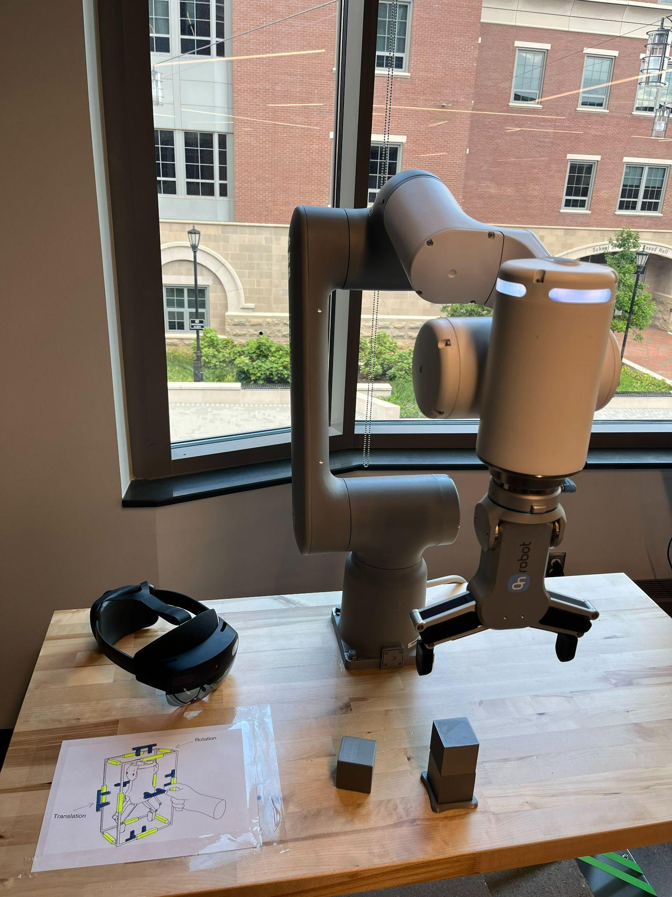

**Introducing our prototype**

Before beginning the experiment, the proctor must give a quick introduction about mixed reality, Hololens, and our prototype. The introduction can be based on the following explanation:

*“Mixed reality provides a connection between virtual reality and our reality. Using a mixed reality headset like Hololens 2, you can visualize, interact and manipulate digital elements in the real world. This is done through the cameras and lenses of the mixed reality headset, who can track the environment, hands positions and display the digital components on a real environment. When you try the prototype for the first time you will be greeted with a holographic box overlaying the robotic gripper. To move the robot from one position to another you must pinch the handles and move towards the direction you want the robot to move. Blue handles are used for translation movements (left, right, up, down, etc) and yellow handles are used for rotation. Remember to align your head in the direction of the hand making the gesture, so the headset cameras can track it. Make sure that the tip of your index finger and thumb are visible when pinching the handles. To open and close the gripper simply look at your hand with your palm facing you and use the pinch slider to open and close the grippers.”*

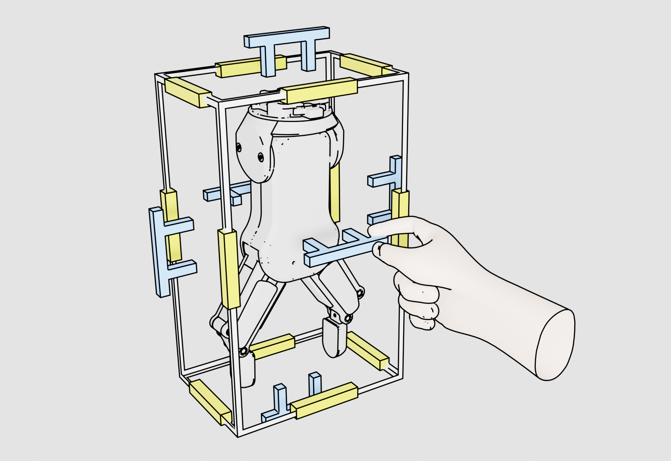

**Conversation with participant:**

After a quick introduction about our prototype, and once the participant tested it, the proctor should ask them about the overall experience. **The conversations must be recorded in audio format and later transcribed into text**. **Try to get as muck feedback as possible from the participant.** Three questions can be used to guide the conversation between proctor and participant:

* **Question I:** Tell us your impressions about using Mista to move the robot (What you find positive and negative about it).
* **Question II:** Do you believe that Mista could be utilized for real world / industrial applications?
* **Question III:** For future developments, how would you improve Mista?

Feel free to explore other questions regarding our prototype during the conversation with the participant, just make sure your voices are being recorded.

**Transcription of audio recordings to text**

Once you have all the recordings done, please transcribe them to text using different documents for each participant. Save the audio files and text files in a Google Drive folder or upload them to our GitHub repository (<https://github.com/vcuse/mista>). Once you are done, report your progress to your supervisor.